If you have had prolonged close contact (less than 6 feet for >10 minutes) with a PATIENT who was OR was NOT wearing a facemask (i.e. SOURCE control), your risk is based upon what PPE YOU (the provider) were wearing.
Regardless of your risk exposure level, you may continue to work. A facemask must be worn and you will need to actively monitor yourself for fever, shortness of breath, or cough TWICE a day while on and off duty.
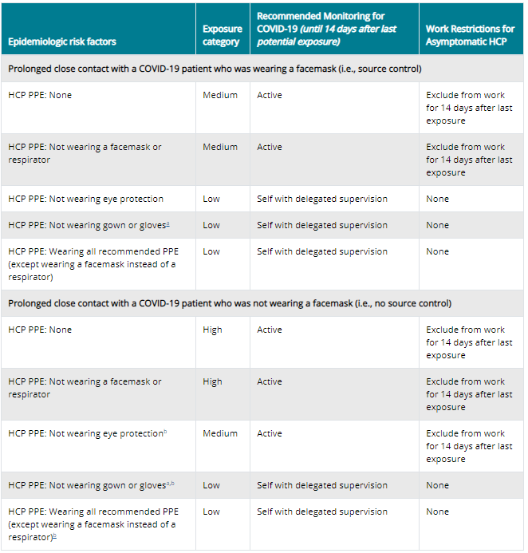
HCP=healthcare personnel; PPE=personal protective equipment
ªThe risk category for these rows would be elevated by one level if HCP had extensive body contact with the patients (e.g., rolling the patient)
^{b}The risk category for these rows would be elevated by one level if HCP performed or were present for a procedure likely to generate higher concentrations of respiratory secretions or aerosols (e.g., cardiopulmonary resuscitation, intubation, extubation, bronchoscopy, nebulizer therapy, sputum induction). For example, HCP who were wearing a gown, gloves, eye protection and a facemask (instead of a respirator) during an aerosol-generating procedure would be considered to have a medium-risk exposure.

Should you develop symptoms and be confirmed by a positive test (or diagnosis based on suspicion), you will need to be on isolation and follow guidance for home care.
The following criteria must be met to determine removal from isolation:
Non-Testing Based Strategy for Removal from Isolation:
Person(s) with COVID-19 who have symptoms and were directed to care for themselves at home may discontinue home isolation under the following conditions:
- 3 days (72 hours) have passed since fever has resolved without use of fever-reducing medications AND respiratory symptoms have improved (e.g., cough, shortness of breath); AND
- 7 days have passed since symptoms first appeared

As a healthcare provider, once you have met the above criteria, return to work practices and work restrictions below will need to be followed:
- Wear a facemask at all times while in the healthcare facility until all symptoms are completely resolved or until 14 days after illness onset, whichever is longer
- Be restricted from contact with severely immunocompromised patients (e.g., transplant, hematology-oncology) until 14 days after illness onset
- Adhere to hand hygiene, respiratory hygiene, and cough etiquette in CDC’s interim infection control guidance (e.g., cover nose and mouth when coughing or sneezing, dispose of tissues in waste receptacles)
- Self-monitor for symptoms, and seek re-evaluation from occupational health if respiratory symptoms recur or worsen.

Crisis Strategies to Mitigate Staffing Shortages
Healthcare systems, healthcare facilities, and the appropriate state, local, territorial, and/or tribal health authorities might determine that the recommended approaches cannot be followed due to the need to mitigate HCP staffing shortages. In such scenarios:
- HCP should be evaluated by occupational health to determine appropriateness of earlier return to work than recommended above
- If HCP return to work earlier than recommended above, they should still adhere to the Return to Work Practices and Work Restrictions recommendations above.

